Certificate of Attendance

Presented to

For attending the

GCSG 2020 Global Virtual Conference
September 21st – September 25th, 2020

Sherri Willson  GCSG 2020  Global Virtual Conference Co-Chair |  | 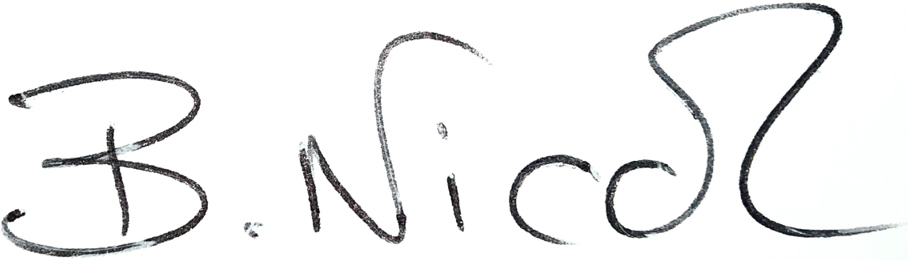  Bev Nicol  GCSG 2020  Global Virtual Conference Co-Chair

